**7. Create web page using HTML5 canvas element to illustrate all canvas composition. Output must exactly look like the following screenshot:**

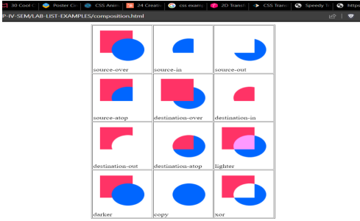

**HTML CODE:**

<!DOCTYPE HTML>

<html>

<head>

<script>

var compositeTypes=[

'source-over','source-in','source-out','source-atop',

'destination-over','destination-in','destination-out','destination-atop',

'lighter','darker','copy','xor'

];

function drawShape(){

for(i=0;i<compositeTypes.length;i++){

var label=document.createTextNode(compositeTypes[i]);

document.getElementById('lab'+i).appendChild(label);

var ctx=document.getElementById('t'+i).getContext('2d');

ctx.fillStyle="#FF3366";

ctx.fillRect(15,15,70,70);

ctx.globalCompositeOperation=compositeTypes[i];

ctx.fillStyle="#0066FF";

ctx.beginPath();

ctx.arc(75,75,35,0,Math.PI*2,true);

ctx.fill();

}

}

</script>

</head>

<body onload="drawShape();">

<table border="1" align="center">

<tr>

<td><canvas id="t0" width="125" height="125"></canvas><br/>

<label id="lab0"></label>

</td>

<td><canvas id="t1" width="125" height="125"></canvas><br/>

<label id="lab1"></label>

</td>

<td><canvas id="t2" width="125" height="125"></canvas><br/>

<label id="lab2"></label>

</td>

</tr>

<tr>

<td><canvas id="t3" width="125" height="125"></canvas><br/>

<label id="lab3"></label>

</td>

<td><canvas id="t4" width="125" height="125"></canvas><br/>

<label id="lab4"></label>

</td>

<td><canvas id="t5" width="125" height="125"></canvas><br/>

<label id="lab5"></label>

</td>

</tr>

<tr>

<td><canvas id="t6" width="125" height="125"></canvas><br/>

<label id="lab6"></label>

</td>

<td><canvas id="t7" width="125" height="125"></canvas><br/>

<label id="lab7"></label>

</td>

<td><canvas id="t8" width="125" height="125"></canvas><br/>

<label id="lab8"></label>

</td>

</tr>

<tr>

<td><canvas id="t9" width="125" height="125"></canvas><br/>

<label id="lab9"></label>

</td>

<td><canvas id="t10" width="125" height="125"></canvas><br/>

<label id="lab10"></label>

</td>

<td><canvas id="t11" width="125" height="125"></canvas><br/>

<label id="lab11"></label>

</td>

</tr>

</table>

</body>

</html>